Bank Term Deposit Subscription Prediction Using Machine Learning

Md. Afsarul Islam Bhuiyan
Dept of Computer Science and Engineering
East West University
Dhaka, Bangladesh
2022-3-60-300@std.ewubd.edu
Shaptashi Brahma Joya
Dept of Computer Science and Engineering
East West University
Dhaka, Bangladesh
2022-3-60-326@std.ewubd.edu
Shadia Islam Mim
Dept of Computer Science and Engineering
East West University
Dhaka, Bangladesh
2022-3-60-132@std.ewubd.edu

Abstract:
Bank telemarketing efforts frequently experience low response rates because of severely imbalanced customer data. It is very complicated the effectively identification of potential subscribers. This research presents a machine learning framework to forecast customer subscriptions to bank term deposits utilizing the UCI Bank Marketing dataset. This includes numerical and categorical characteristics. To tackle data imbalance and enhance model performance, preprocessing techniques like categorical encoding, outlier management, and class balancing through the Synthetic Minority Over-sampling Technique (SMOTE) were employed. Four classification models, Logistic Regression, Support Vector Machine (SVM), Decision Tree, and Random Forest, were assessed. Experimental findings indicate that SVM attained the greatest recall (0.93) and ROC-AUC (0.93) for the minority class, demonstrating its effectiveness in recognizing potential subscribers. Logistic Regression exhibited the most consistent and well-rounded overall performance, whereas Random Forest attained greater accuracy but proved less effective in identifying instances of the minority class. The results suggest that integrating machine learning models with suitable preprocessing and resampling methods can greatly enhance the success of bank marketing campaigns by facilitating more focused and cost-effective customer engagement.
Keywords: machine learning model, SMOTE, support vector machine (SVM), classification, imbalance learning, Decision Tree.
1. Introduction
The banking sector of the present day has turned to data-oriented methods considerably more and more in its quest to acquire and keep customers. Direct marketing campaigns, phone-based telemarketing in particular, are still regarded as a major channel for the sale of financial products like term deposits. These campaigns usually consist of making calls to potential customers to persuade them to invest in the long-term products. Nevertheless, it is still very hard to detect the customers who are most likely to react positively because there are too many to contact, and the clients have very different characteristics. To enable data-driven decision-making, the machine learning approach has been favored by the researchers and practitioners who built predictive models based on the historical data that classify potential subscribers and non-subscribers.
Here, we used the Bank Marketing Dataset from the UCI Machine Learning Repository. The dataset consists of demographic features (like age, profession, and marital status), financial data (like account balance), and features of the campaign (like the way of contacting and the number of contacts). Moro et al. (2014) [1] showed that the largest part of the contacted clients did not take term deposits, pointing out major drawbacks in the traditional approach of the telemarketing process. The low success rates make the cost of operations go up and also lead to the customers being less satisfied.
We applied the Bank Marketing dataset from the UCI Machine Learning Repository. The data consist of extensive information regarding the client’s demographics, financial status, and past interactions with the bank's marketing campaign. The objective was to explore the dataset, identify patterns in subscription determinants, and build machine learning predictors for client’s subscription propensity.
Recent years have seen significant research on Fairness-Aware Machine Learning, especially in financial applications. Now that automated decision-making is common, it is important to ensure that predictive systems do not result in discrimination across demographic groups. Although Fairness concerns can arise at different levels of the modeling pipeline, Upstream. The first point of concern for fairness can be the way data is collected or segmented downstream. Upon reaching the model's prediction stage. Various frameworks have been proposed for ensuring demographic fairness during the clustering phase, increasing their robustness when they receive incomplete or noisy sensitive variable input, and incorporating fairness constraints into ensemble methods that take class imbalance into consideration. All of this work provides guidance for building trustworthy and fair predictive models for bank marketing.
Another important challenge in predictive modeling is class imbalance and possible changes in subscription rates over time, known as prior probability shift. Changes in the number of subscribers across different campaigns can impact model performance if not taken into account. Recognizing this issue helps make classification models trained on this dataset stronger and more adaptable.
To address these issues, this paper introduces several innovations:
- It compares the performance of various supervised machine learning algorithms, which include traditional classifiers and ensemble models, on the Bank Marketing dataset.
- It explores the influence of preprocessing methods, such as dealing with class imbalance and encoding categorical features, on the performance of the models.
- It measures the effectiveness of the models using a range of metrics. Not just accuracy, including precision, recall, F1-score, and ROC-AUC, resulting in a more complete evaluation of the behavior of classifiers.
This research will create a comprehensive prediction framework for subscribers to term-deposit products by analyzing the UCI Bank Marketing Dataset. As such, while the goal is to develop a strong predictor, we will also attempt to ground our prediction efforts on an approach that incorporates fairness, noise tolerance, and resistance to distribution shifts in our methods used from current machine learning literature. The next section will provide an overview of the relevant literature in these areas that have informed our design of this project.
2. Literature Review
All the methods proposed in the literature to predict bank term deposit subscriptions mainly differ in customer behavior modeling, data imbalance treatment, and interpretability settings. The existing methods frequently refer to the UCI Bank Marketing dataset [19] as a standard, which consists of 45,211 instances with features such as age, job, marital status, education, balance, housing, loan, contact type, duration, campaign contacts, pdays, previous, poutcome, and the target (subscription yes/no). This dataset has a heavy imbalance (88.9% no subscriptions), which calls for specific techniques to deal with it. According to the methodological perspective, we may easily categorize the above-mentioned techniques into four groups: (A) Data-driven prediction models using traditional ML [1-4]; (B) techniques for handling class imbalance [5-9]; (C) advanced and deep learning methods [10-12]; and (D) model interpretability and fairness approaches [13-18]. The next sections will cover the existing and modern prediction methods that belong to these categories.
2.1. Data-Driven Prediction Models
Moro et al. [1] have used data mining approaches like decision trees, neural networks, and Support Vector Machine (SVM). The study was conducted on a Portuguese bank telemarketing dataset consisting of 45,211 records. Feature selection, data normalization, and 10-fold cross-validation were used as the preprocessing steps. Out of all methods employed in the study, the neural network took the lead in becoming the most accurate, with a 79% success rate. Hence, predicting the successful subscription better than the rest. Nevertheless, the study pointed out that there were still some issues that needed to be looked into when it came to class imbalance. This could be the cause for the lower recall rate of the positive cases. In order to better detect the minority classes in future work, we will use oversampling, join, or ensemble techniques for robustness. Continuing with these initial data-oriented methods and overcoming their drawbacks with respect to imbalance handling, later research delved into more sophisticated tree-based techniques. Safarkhani and Moro et al. [2], the researchers in this work, applied decision trees (C4.5 and CART) to the UCI dataset, integrating resampling to manage the imbalance and feature selection for optimization. The C4.5 algorithm obtained 93.961% accuracy. One of the potential gaps is the restricted investigation of ensemble methods, which could improve the resistance to noise. The method also presumes equivalent lighting conditions in analogies, but for deposits, real-time data fluctuations are not accounted for, thus recommending hybrid models with boosting. Recent studies have gradually shifted the attention from traditional machine learning practices to deep learning architectures that are able to recognize time-dependent patterns in banking data. In Tuan et al. [3], the authors implemented recurrent neural networks such as LSTM, GRU, BiLSTM, BiGRU, and SimpleRNN on a banking term deposit dataset. The preprocessing included string-to-numeric conversion and embedding layers. The GRU model obtained a 90.8% accuracy rate. The gaps lie in not comparing with traditional ML methods and not addressing class imbalance, which could lead to overfitting. Therefore, they proposed the use of SMOTE and XAI for obtaining a more generalizable model. Ensemble learning approaches have been investigated for their robustness and predictive ability in complement to neural network-based methods. Olajide and Ishaku et al. [4] applied Random Forest and SVM on a term deposit dataset after data preprocessing and cross-validation. The Random Forest model got 95% accuracy. A possible shortcoming is the absence of quantitative measures, such as the F1-score interpretability, which limits practical insights.
2.2. Techniques for Handling Class Imbalance
Chawla et al. [5] proposed the SMOTE technique, through which minority classes are subjected to oversampling by producing synthetic instances in the manner of lines drawn between the k-nearest neighbors. SMOTE achieved an improvement of up to thirty percent in F1-scores when compared to the sole use of undersampling based on the tests conducted with the C4.5 and Ripper classifiers on various imbalanced datasets. One of the possible weaknesses of the method is the exposure to the noise in the data, which eventually leads to the errors being amplified. However, it is the Geometric SMOTE extension in particular that is recommended for the geometric enhancements in the very high-dimensional spaces, such as those banking features. The limitations of the SMOTE of this kind were resolved using advanced techniques. Douzas and Bacao et al. [6] introduced the Geometric SMOTE, which synthesizes samples inside hyperspheres around the minority instances. It was significantly superior to SMOTE in 20 datasets when it comes to F1-score (p < 0.05). Among the gaps is the fact that there is a higher computational cost if one works with large datasets. In banking, it could be advantageous in terms of distinguishing the feature correlations, but empirical validation through UCI datasets is required. A very powerful aspect of resampling is that some researchers have merged imbalance handling in their work with strong power ensemble classifiers. Arifah et al. [7] used XGBoost in conjunction with SMOTE for classifying deposits in a dataset characterized by imbalance. After the process of balancing, the measures of the performance reached 91.07% for accuracy, 78.88% for precision, 75.59% for recall, 59.15% for F1, and 0.937 for ROC. One of the areas that could be further explored is that the entire emphasis on a single algorithm without comparisons with others might imply the ensemble integration for the sake of robustness. Also, decent performance improvement has been exhibited by the combination of oversampling with kernel-based classifiers. Abidin et al. [8] reported that incorporating the SMOTE technique with SVM and hyperparameter tuning significantly enhanced the predictive power of bank marketing campaigns. The improved model achieved 91% accuracy and an AUC of 0.96. Besides solutions that work on the data level, there have been algorithm-level approaches that have proposed to straight away involve the imbalance costs in the learning process. Iosifidis et al. [9] proposed AdaCC, which stands for cost-sensitive boosting that dynamically modulates the costs. On 30 datasets, it performed better than AdaBoost and thus led to an increase in AUC by 3.4-21.4%.

2.3. Advanced and Deep Learning Methods
Che et al. [10] conducted a study where they implemented t-SNE for reducing the dimensionality and changing the features of the bank marketing dataset. Then the classification was done on it. The features that were transformed led to an improvement in the model performance to achieve a high accuracy compared to the baselines without transformation. The exploration of deep learning models to understand complex data patterns has gone hand in hand with the transition from basic feature transformation techniques to more sophisticated learning architectures. Hsu et al. [11] developed a neural network architecture based on CNNs for bank direct marketing prediction that uses deep learning. The CNN model was able to attain higher accuracy than traditional classifiers and was also good at recognizing complex patterns in customer data. Representation learning has seen a lot of traction in augmenting customer feature modeling besides convolutional-based methods. Gupta and De [12] proposed the use of neural embedding techniques to create a representation of customer features. Which would help in targeting bank marketing campaigns better. The embeddings led to an increase in the accuracy of machine learning models by revealing the semantic relationships.

2.4. Model Interpretability and Fairness
Lundberg and Lee et al. [13] presented a SHAP approach based on game theory that employed Shapley values to interpret both individual and global predictions of any machine learning model. In the trials that were conducted with different models, SHAP was able to deliver consistent and accurate attributions. Thus bringing about the unification of the post-hoc methods. One of the drawbacks is the high computational cost that is likely to be incurred when large ensembles or instances are used, which is a limitation for real-time usage in the banking sector. This is critical as it relates to both trust and compliance. Thus, the recommendation of efficient approximations such as TreeSHAP for tree-based models. While SHAP offers a unified and theoretically supported framework of explanation, a few other model-agnostic tools have been suggested for improving local interpretability. Ribeiro et al. [14] introduced LIME, which is an interpretable model-agnostic method that creates local explanations for the end-user through the approximation of complex models with simpler surrogate models that depend on specific predictions. Reviews on classifiers affirmed the explanations as being both accurate and intuitive. A few disadvantages or areas of concern are the sensitivity of the method to perturbation choices and that it mainly provides local rather than global insights; thus making it a good complement to SHAP when it comes to banking decisions that require case-by-case justification. Besides being interpretable, one of the purposes of the recent studies has also been fairness in machine learning systems, with a strong emphasis on the data-driven decision-making areas like banking. Bera et al. [15] came up with fair clustering algorithms that would not only provide but also maintain balanced representation among the protected groups while adding a little to the clustering cost. It was found to be less disparate in the benchmarks. Thus, it achieved low disparity. One of the future concerns is the extension to supervised classification tasks, such as deposit prediction, where demographic features may lead to bias. Hence, one of the possible future applications in the banking sector would be auditing customer targeting based on fairness. In order to offer fairness guarantees, alternative clustering approaches have also been suggested that make use of principled optimization constraints. Ziko et al. [16] proposed variational fair clustering, which guaranteed fairness via KL-divergence constraints. It was found to be the case when this method was applied to various datasets. It increased fairness metrics while maintaining the performance level. A gap in this method, though, is its difficulty in scaling to the banking sector, particularly when it comes to the multi-dimensionality of the data. However, there is a suggestion to adapt for balancing classification. Besides fairness-aware clustering, the robustness of classifiers to the data imperfections has been considered. Lamy et al. [17] proposed a classification with fairness under noise conditions that is tolerant to label noise in the sensitive attributes. The researchers carried out their experiments on noisy datasets and effectively minimized the bias that was present.

3. Proposed Methodology
This method uses a structured multi-stage machine learning pipeline to predict whether a client will subscribe to a bank's term deposit. The banking marketing data set is non-linear with significant class imbalance and heterogeneity. Here we train and compare four classification models: logistic regression, decision tree, and random forest.

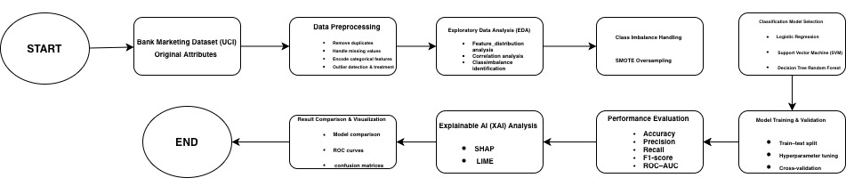

Figure 1: Proposed methodology workflow system
3.1. Classification Algorithms
These models were chosen because of their shown effectiveness in banking marketing forecasting, their capacity to produce a variety of data features, and their frequent application in earlier depositor behavior studies.

Logistic Regression (LR) :
A linear classification model called logistic regression predicts the possibility that an event will occur. We can estimate binary outcomes using a logistic function. It is often used as a baseline model in marketing research in banks due to its simplicity, interpretability, and stability of output (Tuan, 2022; Olajide & Wreford, 2023). When the Yes/No boundary is generally linear, it performs well. It provides an important probability for client ranking (top 10% most likely to subscribe).
Support Vector Machine (SVM): SVM is a margin-based classifier that establishes the optimal border between classes. It may also model nonlinear patterns in the data using kernels. It works well when there are many features (high-dimensional data). For example, the Bank Marketing data has many input features. So, it is a good fit for SVM. It searches for the biggest difference between the classes, or the highest margin. SVMs can efficiently represent nonlinear relationships, which are frequently found in consumer subscription behavior, by utilizing kernel functions. Previous research shows that minority-class recall in bank marketing datasets is much improved by integrating SVM with SMOTE and hyperparameter optimization Abidin et al. [8].
Decision Tree Classifier:
Decision Trees are rule-based models that classify data by dividing it into smaller groups according to feature values. This process creates clear, easy-to-understand decision rules. Research by Safarkhani and Moro et al. [2] shows that Decision Trees effectively identify customer behavior patterns in predicting bank term deposits, especially when proper preprocessing and class imbalance management are used. Their main strength is their transparency, which helps users understand how various customer attributes affect subscription decisions. However, Decision Trees can overfit the data, so it is important to compare them with stronger ensemble methods.

3.2. Random Forest Classifier Here is a simplified version

Random Forest is a model that uses many Decision Trees together. Averaging their results reduces errors and avoids the overfitting problem of a single tree. We chose it because it gives better accuracy, understands complex patterns, and produces more stable and reliable predictions.
These class-weighted loss functions were utilized during model training to give higher importance to correctly identifying minority-class samples, supplementing the class balancing achieved through SMOTE.
3.3 Limitations and Future Directions
Despite the methodology's thoroughness, several drawbacks were identified. Since the dataset is seen as static, it might not be able to record changing advertising tactics or consumer behavior over time. Artificial patterns may be introduced into the data via synthetic oversampling, which might have an impact on performance in the actual world. Additional possibilities for future study include advanced ensemble techniques like gradient boosting machines, dynamic modeling approaches that incorporate temporal changes, and the incorporation of external data sources like transactional histories for richer feature sets. In addition, further deployment of fairness-aware learning frameworks will be critical to operationalize ethical machine learning in banking marketing.
4. Experimental Setup:
4.1. Dataset
The bank's additional full.csv dataset, which includes 20 input variables and 37 41,188 samples, has been used in this investigation. The client’s term deposit subscription status is indicated by the target variable y, which can be either "yes" or "no." Client details ( age, occupation, marital status, education), financial situation ( default, housing, loan), and campaign information (contact type, month, day of week, length) are among the attributes.
4.2. Dataset Description
The dataset consists of 31,851 instances and 17 attributes that comprise a mix of numeric attributes and categorical attributes. The attributes hold a full record of the campaign history and client profile.
Key Features:
- Age: Numeric, the client's age.
- Job: Categorical, the client's occupation type ( technician, admin).
- Marital Status: Categorical, single, married, or divorced.
- Education: Categorical, the level of education of the client.
- Default: Binary, whether the client is in credit default or not.
- Balance: Numerical, client means annual balance in euros.
- Housing Loan: Binary, whether the client has a housing loan or not.
- Personal Loan: Binary, whether a client has a personal loan or not.
- Contact Type: Binary, contact type utilized ( cellular, telephone).
- Day: Numerical and binary, last contact day of the month.
- Month: Numerical and binary, last contact month of year.
- Duration: Numerical, last contact time in seconds.
- Campaign: Numeric, contacts in this campaign.
- Pdays: Numeric, days elapsed since last contact made on previous campaign.
- Previous Contacts: Numeric, number of previous contacts.
- Outcome: Categorical, outcome of the previous marketing campaign.
- Target (y): Categorical, whether client subscribed (1 = yes, 0 = no).
It is evident that the target variable is severely imbalanced, as not many clients are subscribing, and this will be hard for machine learning algorithms to learn from.
4.3. Data Preprocessing
Preprocessing is needed for models to learn properly. Our preprocessing involved:
4.3.1 Missing Values Handling:
We scanned for missing values (NaNs) in all columns.
Columns with missing values were imputed with suitable strategies (e.g., mean or mode) or dropped if not feasible.
4.3.2 Encoding Categorical Features:
Binary-type categorical features (housing, loan) were encoded with Label Encoding.
Features with greater than two classes ( work, education) were encoded with One-Hot Encoding, one binary column per class.
4.3.3. Target Standardization:
The y column target was standardized from yes/no to numeric: yes = 1, no = 0.
4.3.4. Outlier Removal:
High outliers in numeric columns may skew models. We removed rows with values greater than 3 standard deviations (Z-score > 3) for numerical columns like balance and duration.
4.3.5. Balancing Classes:
Target was severely imbalanced (0: 27,477, 1: 2,374). We applied SMOTE (Synthetic Minority Oversampling Technique) and generated synthetic samples for the minority class.
After SMOTE, both classes contained 27,477 samples, where models could learn from both classes equally.
4.4. Training Models
To maintain the class distribution, we used stratified sampling to divide the preprocessed data into a training set (80%) and a testing set (20%). To further punish misclassifications of the minority class, a classifier was created with class_weight='balanced'. The SMOTE-augmented training set was used to train the model.
4.5. Exploratory Data Analysis (EDA)
EDA assists us in finding out the connections and trends within the data before modeling.
4.6. Target Distribution
The target variable had a large class imbalance, according to preliminary exploratory data analysis.
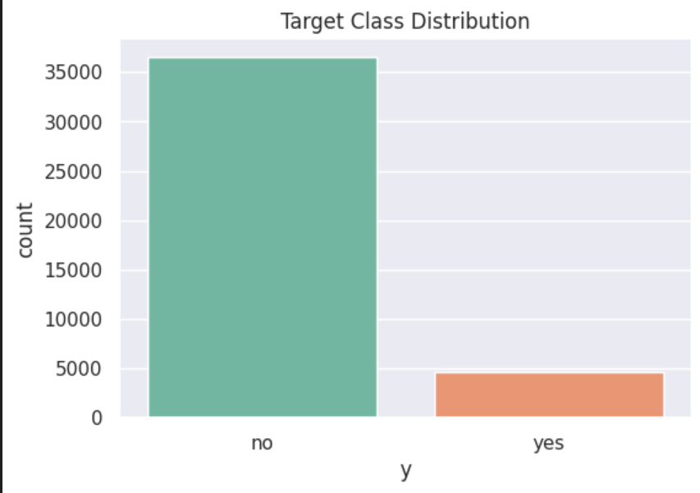
Figure 2. Distribution of the target variable ’y’. The ’no’ class significantly outweighs the ’yes’ class.
There are some strong relationships between specific economic variables that were revealed by the correlation matrix of numerical features.
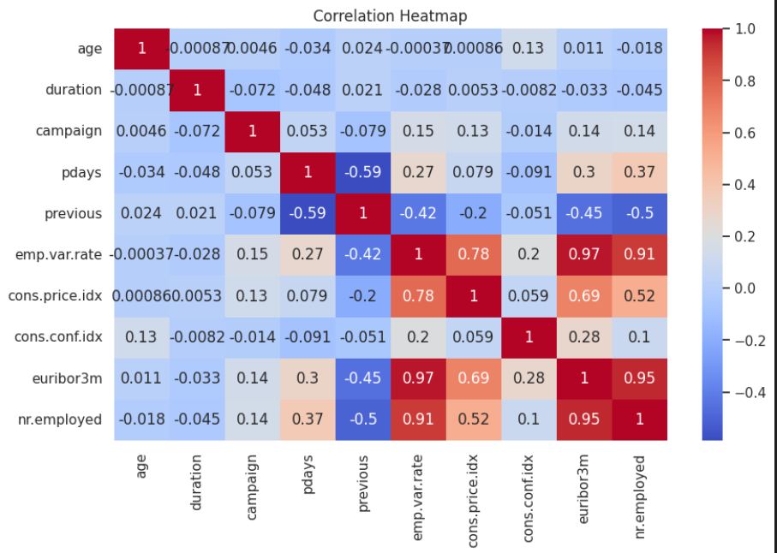
Figure 3. Correlation Matrix of Numerical Features
4.7. Performance Summary:
4.7.1. Logistic Regression:
Test Accuracy: 0.8481, ROC-AUC: 0.9288
High recall (0.88) for subscribers captures most positive examples, but precision (0.33) is low, i.e., few false positives.
Logistic Regression:
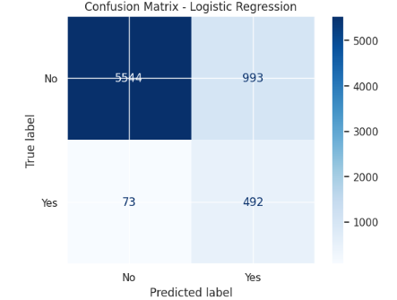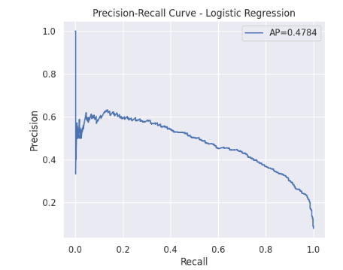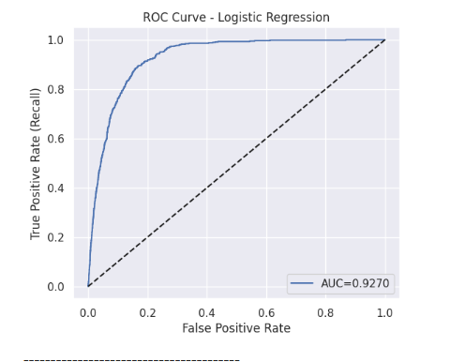
4.7.2. SVM:
  - Test Accuracy: 0.8168, ROC-AUC: 0.9267
  - Recall for subscribers is 0.93, the highest in models, but precision is extremely low (0.29).
Support Vector Machine:
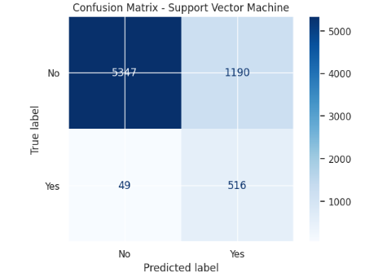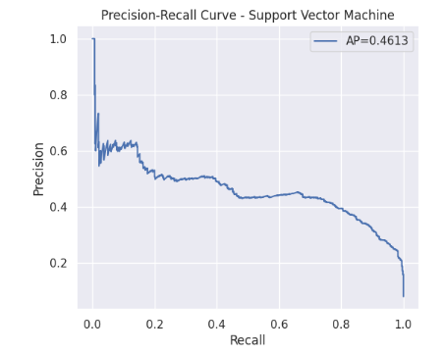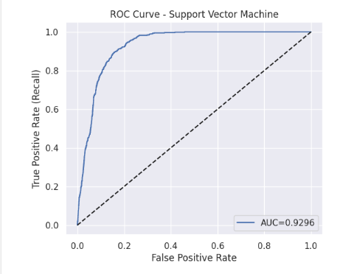

4.7.3. Decision Tree:
- Overfits the training set (0.9968) and performs very badly on test ROC-AUC (0.7102).
- Subscriber recall is 0.48, so it misses a lot of positive cases.
Decision Tree:
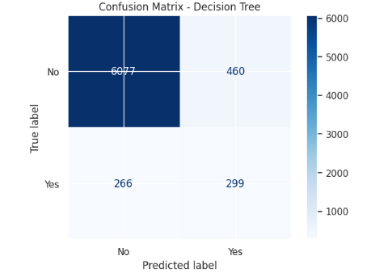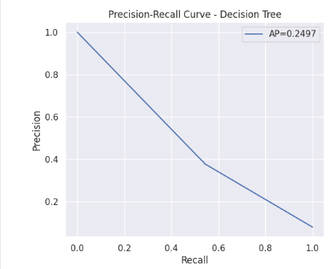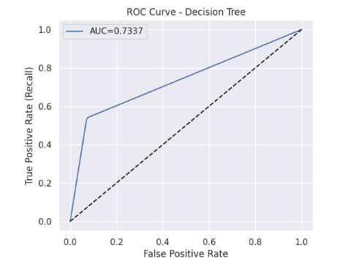

4.7.4. Random Forest:
  - Test Accuracy: 0.9015, ROC-AUC
  - Recall is moderate (0.51) and greater precision than the Decision Tree. Overfits but less than for a single tree.

Random Forest:
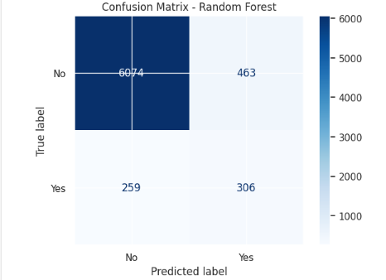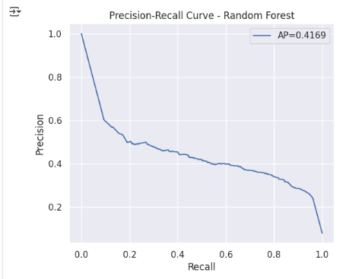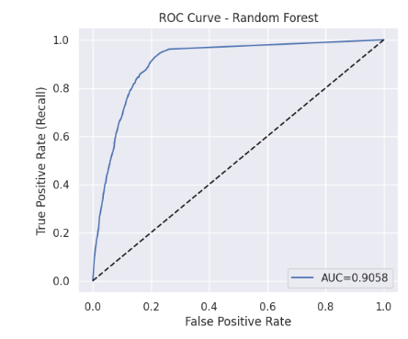
Observations:
- Logistic Regression has consistent performance and quality minority class detection.
- Tree-based models overfit, and Random Forest ensembles are even in need of optimization.
- SVM has high recall and low precision.
4.8. Accuracy Metric Explain:
The accuracy of four machine learning models, Logistic Regression, Support Vector Machine (SVM), Decision Tree, and Random Forest, was compared using confusion matrices, precision-recall curves, and ROC curves. Random Forest and Logistic Regression were relatively better with AUC values of approximately 0.60, though this is still indicative of poor predictive power. On the other hand, Decision Tree and SVM models were poor with AUC values of nearly 0.50, representing random chance. The confusion matrices also indicated rampant misclassifications and class imbalance across all models. In general, the results indicate that there was no predictive performance shown by any of the models. This could be due to class imbalance, lack of good feature representation, or requirements for hyperparameter tuning. In order to improve the accuracy of the model, additional activities such as data preprocessing, feature engineering, and parameter tuning of the model are recommended.
4.9. Comparative Analysis of Model Performance on Two Datasets:
We trained the same set of models, Logistic Regression, SVM, Decision Tree, and Random Forest, on two different CSV files. Below is a comparison of their performance, focusing on accuracy, ROC-AUC, and minority class detection.
4.9.1. Logistic Regression:
Metric | First Dataset | Second Dataset
Training Accuracy | 0.8540 | 0.8540
Test Accuracy | 0.8499 | 0.8499
Test ROC-AUC | 0.9288 | 0.9270
Recall for Yes | 0.88 | 0.87
Precision for Yes | 0.33 | 0.33
Observation:
- Logistic Regression remains stable across datasets, with very similar accuracy and ROC-AUC.
- Recall for the minority class (subscribers) is consistently high (~0.87-0.88), ensuring most positive cases are detected.
- Precision is low in both datasets, indicating the model predicts some false positives.
4.9.2. Support Vector Machine (SVM):
Metric | First Dataset | Second Dataset
Training Accuracy | 0.8783 | 0.8702
Test Accuracy | 0.8168 | 0.8255
Test ROC-AUC | 0.9267 | 0.9296
Recall for Yes | 0.93 | 0.91
Precision for Yes | 0.29 | 0.30
Observation:
- SVM slightly underperforms compared to Logistic Regression in accuracy, but still maintains a high ROC-AUC.
- Recall is slightly lower in the new dataset (0.91 vs 0.93), but precision is marginally better (0.30 vs 0.29).
- Indicates that SVM is robust, but may slightly overfit the first dataset.
4.9.3. Decision Tree:
Metric | First Dataset | Second Dataset
Training Accuracy | 0.9968 | 0.9974
Test Accuracy | 0.8982 | 0.8978
Test ROC-AUC | 0.7102 | 0.7337
Recall for Yes | 0.48 | 0.53
Precision for Yes | 0.39 | 0.39
Observation:
- Decision Tree overfits training data in both datasets (accuracy ~ 0.997).
- ROC-AUC improves slightly on the second dataset (0.7337 vs 0.7102), showing marginally better ranking ability.
- Recall increases from 0.48 → 0.53, meaning it detects slightly more subscribers.
- Precision remains the same (0.39), still indicating some false positives.
4.9.4. Random Forest:
Metric | First Dataset | Second Dataset
Training Accuracy | 0.9968 | 0.9973
Test Accuracy | 0.9015 | 0.8983
Test ROC-AUC | 0.8950 | 0.9058
Recall for Yes | 0.51 | 0.54
Precision for Yes | 0.41 | 0.40
Observation:
- Random Forest overfits slightly in both datasets (training ~ 0.997).
- ROC-AUC improves on the second dataset (0.9058 vs 0.8950), suggesting better ranking ability.
- Recall for the minority class increases (0.54 vs 0.51), with slightly better subscriber detection.
- Precision is comparable, slightly lower (0.40 vs 0.41).
4.10. General Insights from Comparison
- Stability of Logistic Regression:
- Logistic Regression is consistent across datasets, providing a good trade-off between accuracy and minority class recall.
- Its precision remains low, meaning false positives are still a challenge.
- SVM Robustness:
- SVM maintains high recall and ROC-AUC, but test accuracy fluctuates slightly.
- Tree-based Models:
- Decision Tree consistently overfits, with only marginal improvement in ROC-AUC and recall on the second dataset.
- Random Forest generalizes better than a single tree and shows slightly improved ROC-AUC and recall on the second dataset.
- Minority Class Detection:
- In both datasets, the minority class (Yes) recall is higher for Logistic Regression and SVM, but the precision is low.
- Tree-based models improve precision slightly but often miss more positive cases (lower recall).
- Dataset Sensitivity:
- Models are largely stable across datasets, but small differences in ROC-AUC, recall, and test accuracy indicate that dataset characteristics (number of samples, feature distributions) can influence model performance.
5. Results and Discussion
Discussion :
The results show that the SVM model trained on SMOTE-balanced data is incredibly successful in finding possible subscribers. The model properly identifies 93% of the real subscribers, as indicated by the high recall of 0.93 for the "Yes" class. For a marketing campaign whose main objective is to avoid missing out on potential clients, this is an essential metric. On the other hand, the precision for the "Yes" class is only 0.29. The result suggests that while the model attracted most customers, it produced a large number of false positives because it predicted yes when the event was not. As for many business scenarios, this trade-off is acceptable if the cost of a missed opportunity (false negative) is greater than the cost of a missed call (false positive).
6. Conclusions:
The study found that a machine learning-based approach was developed to predict customer subscriptions to bank term deposits. The dataset contains both categorical and numerical, and shows a strong imbalance between subscribers and non-subscribers. Using SMOTE, we found that data preprocessing steps, including categorical encoding, outlier treatment, and class balancing, played a significant role in improving the model's performance. Of all the models tested, logistic regression performed the most stably and reliably. It correctly identified most of the customers who had actually subscribed to term deposits. and also showed strong overall classification ability, as reflected by a high ROC–AUC score. Although Random Forest achieved higher overall accuracy, it showed limited ability to correctly identify minority-class instances. Instead of contacting every customer at random, the suggested approach can assist bank marketing teams in concentrating their efforts on those who are more likely to subscribe. This focused strategy can cut down on pointless calls, save money and time, and boost marketing campaigns' overall success rate. To further enhance prediction performance, future research can concentrate on utilizing more advanced machine learning models like XGBoost or LightGBM. Precision and recall can also be more successfully balanced by using class weighting or modifying decision thresholds. These models' overall reliability can be improved, and overfitting can be decreased with additional hyperparameter tuning.
Acknowledgments: We acknowledge the UCI Machine Learning Repository for making the dataset available.
Conflicts of Interest: The authors declare no conflict of interest.
References:
- Moro, Sérgio & Cortez, Paulo & Rita, Paulo. (2014). A Data-Driven Approach to Predict the Success of Bank Telemarketing. Decision Support Systems. 62. 10.1016/j.dss.2014.03.001.
- Safarkhani, Fereshteh & Moro, Sérgio. (2021). Improving the Accuracy of Predicting Bank Depositor’s Behavior Using a Decision Tree. Applied Sciences. 11. 9016. 10.3390/app11199016.
- Tuan, Sakya. (2022). Machine Learning Performance on Predicting Banking Term Deposit.
- Olajide Olajide, B., & Ishaku Wreford, A. (2023). Bank Term Deposit Service Patronage Forecasting using Machine Learning. Vallis Aurea, 9(2), 53-64.
- Chawla, Nitesh & Bowyer, Kevin & Hall, Lawrence & Kegelmeyer, W.. (2002). SMOTE: Synthetic Minority Over-sampling Technique. J. Artif. Intell. Res. (JAIR). 16. 321-357. 10.1613/jair.953.
- Douzas, G., & Bacao, F. (2019). Geometric SMOTE a geometrically enhanced drop-in replacement for SMOTE. Information sciences, 501, 118-135.
- Arifah, Dina & Saragih, Triando Hamonangan & Kartini, Dwi & Muliadi, Muliadi & Mazdadi, Muhammad. (2023). Application of SMOTE to Handle Imbalance Class in Deposit Classification Using the Extreme Gradient Boosting Algorithm. Jurnal Ilmiah Teknik Elektro Komputer dan Informatika. 9. 396-410. 10.26555/jiteki.v9i2.26155.
- Abidin, D. Z., Rosario, M., Sadikin, A., Nurhadi, N., & Jasmir, J. (2025). Improving Term Deposit Customer Prediction Using Support Vector Machine with SMOTE and Hyperparameter Tuning in Bank Marketing Campaigns. Jurnal Teknik Informatika (Jutif), 6(3), 1267-1278.
- Iosifidis, V., Papadopoulos, S., Rosenhahn, B., & Ntoutsi, E. (2023). AdaCC: cumulative cost-sensitive boosting for imbalanced classification. Knowledge and Information Systems, 65(2), 789-826.
- Q. Che, M. Ding, and L. Liu, “t-SNE-Based Feature Transformation for Bank Marketing Classification,” Journal of Service Science and Management, vol. 13, pp. 831–846, 2020.SCIRP
- Hsu, T., Chen, J., Chen, W., Chien, Y., Wu, S., Ashouri, M., Che, Lin, & Shmueli, G. (2018). A Deep Learning Approach To Bank Direct Marketing.
- S. Gupta and R. De, “Neural Embedding Methods for Customer Targeting in Bank Marketing,” International Journal of Machine Learning, vol. 14, 2022.https://www.sciencedirect.com/science/article/pii/S0167811622000180
- Lundberg, S. M., & Lee, S. I. (2017). A unified approach to interpreting model predictions. Advances in neural information processing systems, 30.
- Ribeiro, M. T., Singh, S., & Guestrin, C. (2016, August). " Why should I trust you?" Explaining the predictions of any classifier. In Proceedings of the 22nd ACM SIGKDD international conference on knowledge discovery and data mining (pp. 1135-1144).
- S. Bera, D. Chakrabarty, N. Flores, and M. Negahbani, “Fair Algorithms for Clustering,” arXiv preprint arXiv:1901.02393, 2019.arXiv
- Ziko, I. M., Yuan, J., Granger, E., & Ayed, I. B. (2021, May). Variational fair clustering. In Proceedings of the AAAI Conference on Artificial Intelligence (Vol. 35, No. 12, pp. 11202-11209).
- Lamy, A., Zhong, Z., Menon, A. K., & Verma, N. (2019). Noise-tolerant fair classification. Advances in neural information processing systems, 32.
- Vaz, A. F., Izbicki, R., & Stern, R. B. (2019). Quantification under prior probability shift: The ratio estimator and its extensions. Journal of Machine Learning Research, 20(79), 1-33.
- S. Moro, “Bank Marketing Dataset Repository,” Kaggle & GitHub, 2014–2022.GitHub+1

